

Department of Dance  Towson University  8000 York Road  Towson, MD 21252-0001  t. 410 704-4527  f. 410 704-3752 | February 5, 2018  To Whom It May Concern:  This is a letter of recommendation for Lia Karagianopoulos, who has just been graduated after completing her last 64 credits in three semesters here. In spite of the high credit load she carried and the fact that she was performing both with the university and with a regional professional company, she earned a GPA of 3.83 while completing her B.F.A. She was inducted into the National Honors in Dance Arts Society during her tenure at Towson, and graduated Cum Laude. I am writing as her advisor and the instructor for her ballet and composition classes.  I enjoyed advising Lia because she was intelligent, she had an open mind an enthusiastic, positive demeanor that lit up our conversations together. I have watched Lia perform in pieces ranging from pedestrian work through quirky release-based modern and Horton Technique all the way into contemporary ballet work. She is a talented performer and a “work horse” – athletic, healthy, committed, responsive to feedback, consistent, and able to take risks when asked. She has a powerful presence on-stage and a wide range of movement qualities she continues to expand. I hope she included the choreography she developed for her dance for the camera duet, because through watching it you can see her maturity and ability both as a performer and as a choreographer. In both fields (performance and composition) I believe Lia is already a mature, intelligent and emotionally evocative artist. She can stand out as a soloist and also adapt to an ensemble role. She can collaborate with a co-creator but also has ideas of her own and a desire to learn and create more. She stays in shape, completes everything she starts, shows up consistently, and is already developing her vision as a creator.  I hope you will seriously consider hiring Lia, and believe you will enjoy her perseverance, competence, talent and emotional maturity. Please feel free to get in touch with me if you would like to know more about my work with her, or have any questions you would like to ask.  Sincerely,  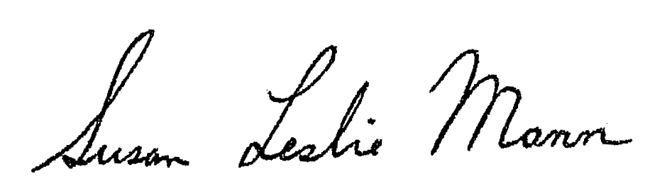  Professor Susan Mann

